*Q.Implement mobile web client application using Javascript,html,CSS.*

A. By using all these tools I implemented basic Google map and its service Geo location is also done. Geo location service is nothing but, it is the process of finding associated geographic coordinates(often expressed as latitude and longitude) from other geographic data, such as street address, or Zip codes (Postal codes).

Home page contains Header(Google map services) and two elements(map directions,Geocoding service)

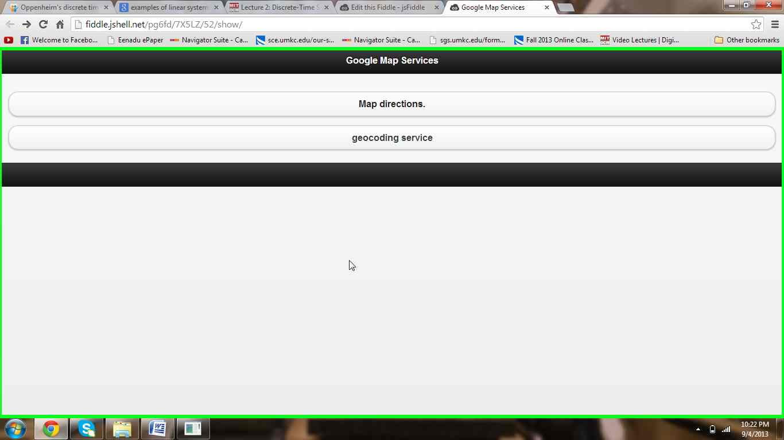

On clicking the button, map directions we get the following map

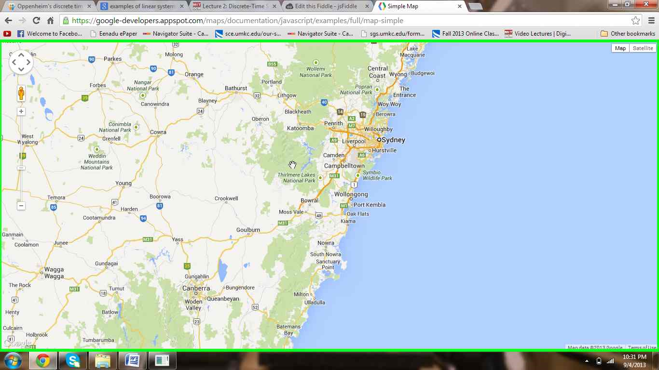

On clicking the Geolocation services button we get the following map.

